**DATABASE MANAGEMENT SYSTEM**

**LAB-5**

**JOINS**

**NAME: VISHWAS M**

**SRN : PES2UG20CS390**

**SEC : F**

**DATE : 25/09/2022**

1) Update price of the ticket.

view1(PNR,Train_no, Departure,Arrival, Distance, FareperKM)

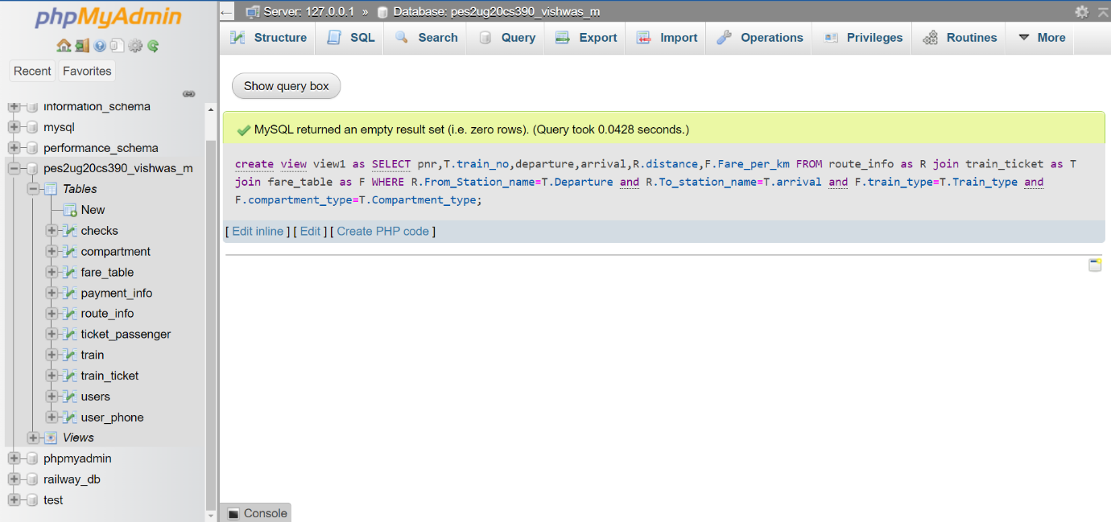

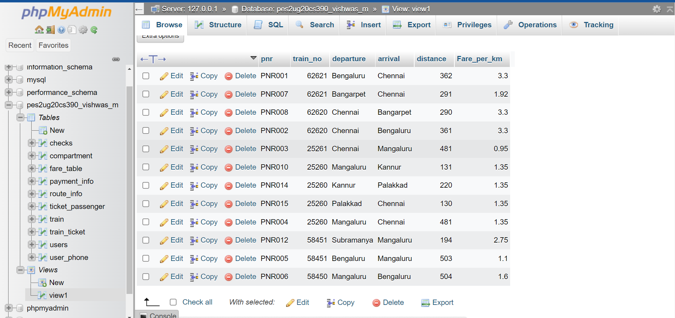

view2(PNR, Passenger_number)

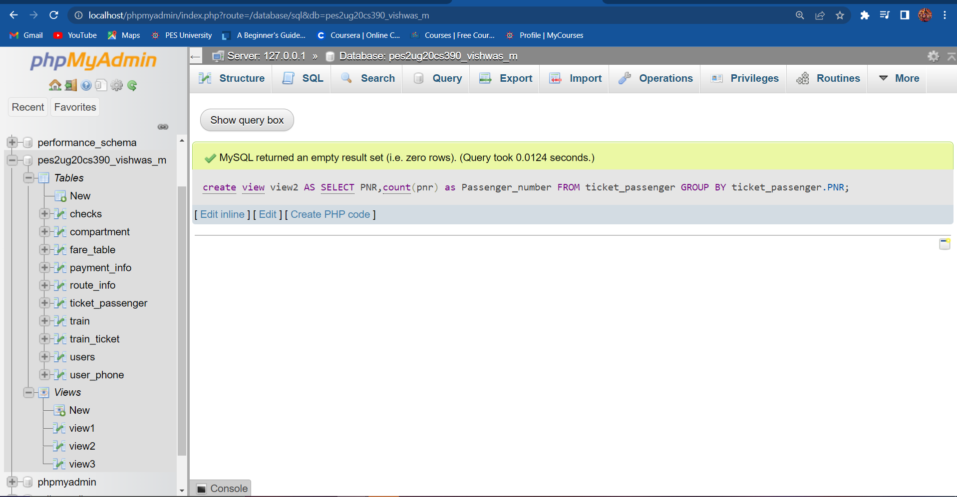

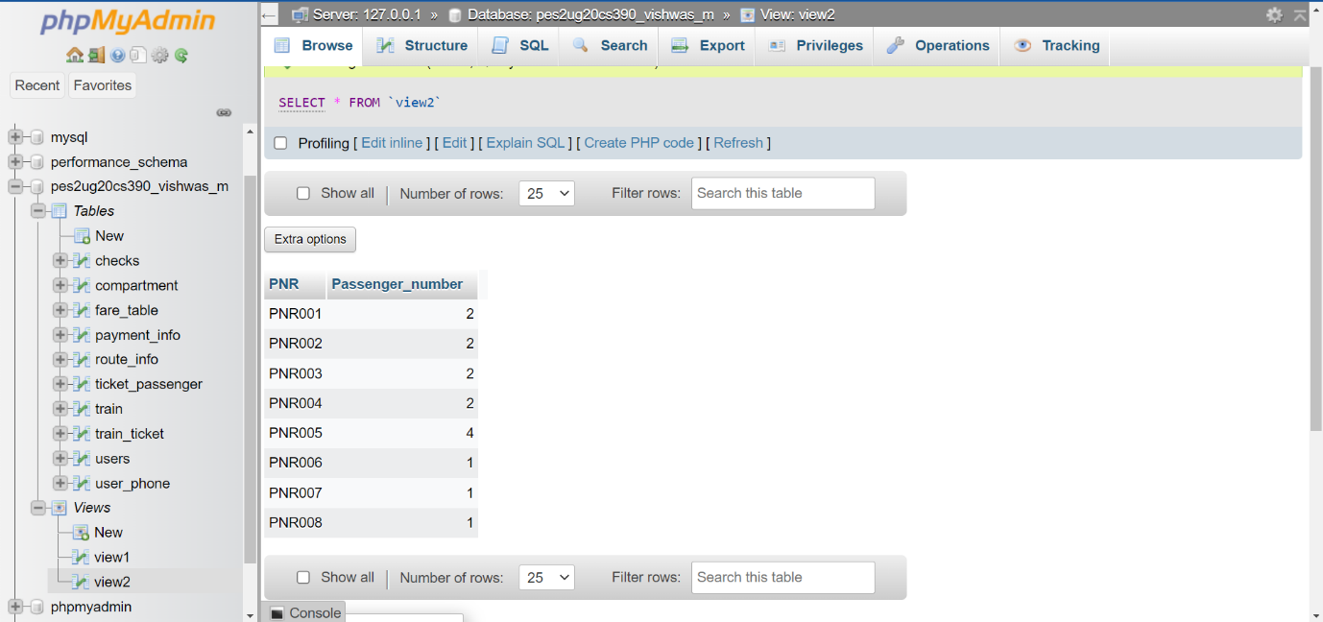

Updating price column in Payment_info table:

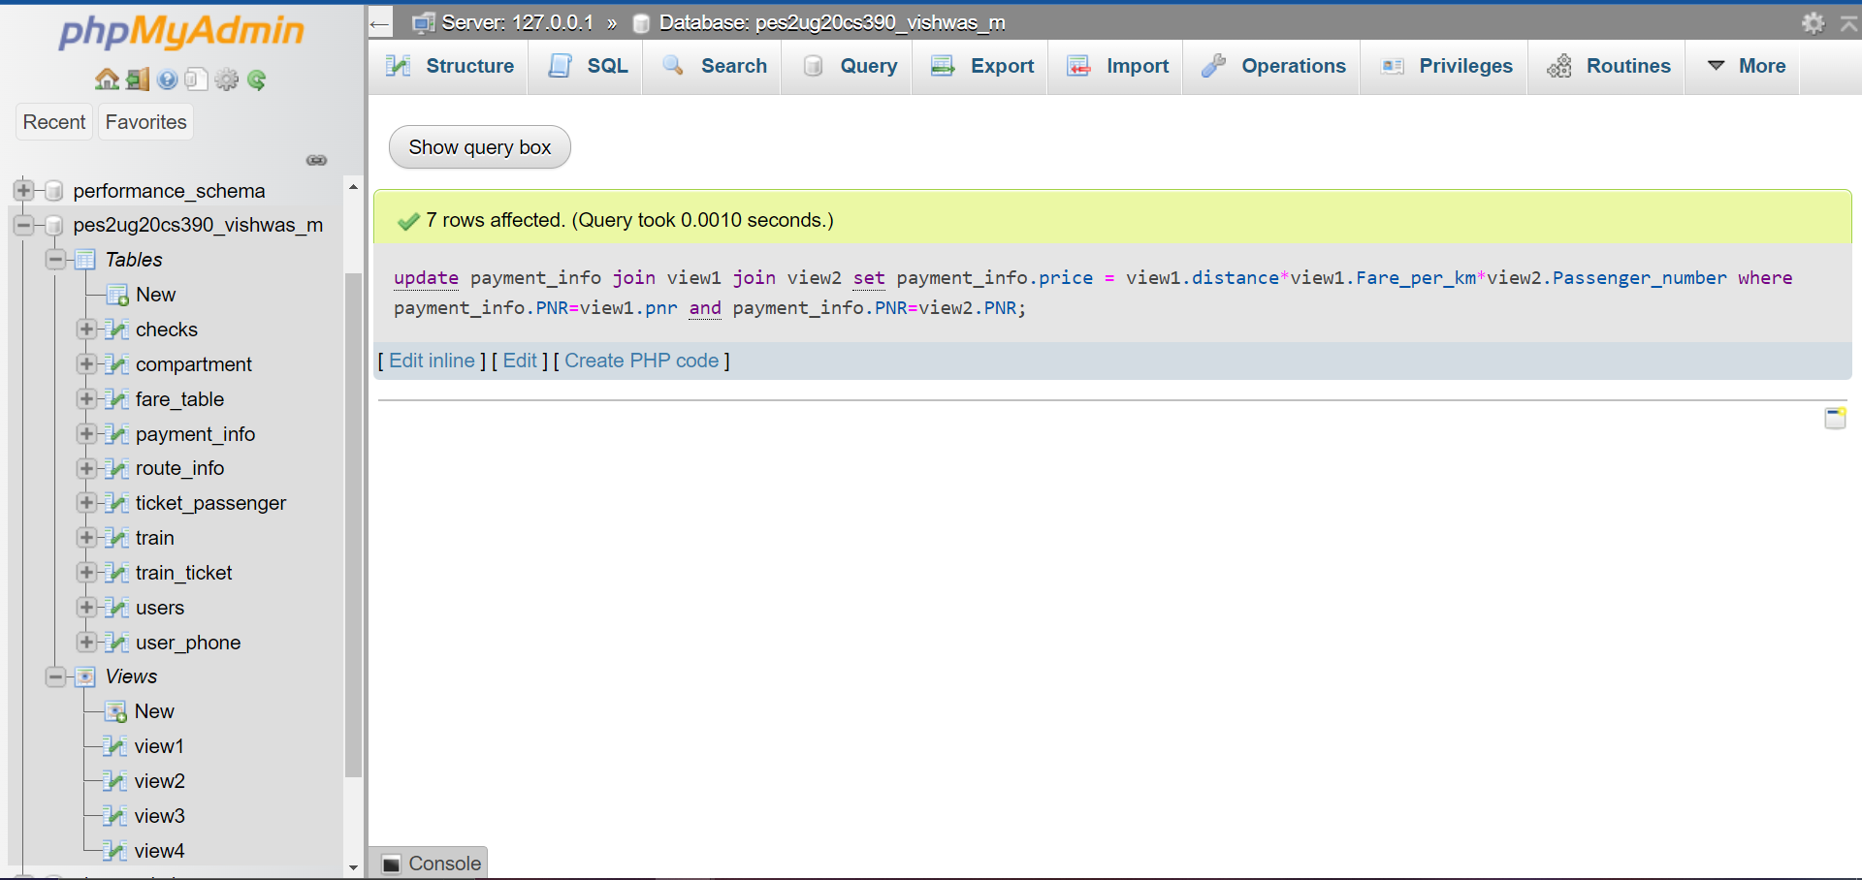

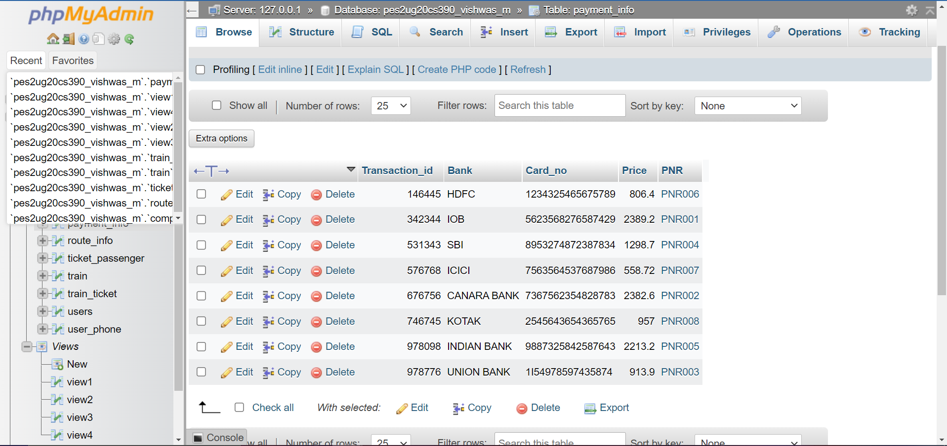

2) Retrieve all the stations along route of the Trains along with the distance between subsequent stations.

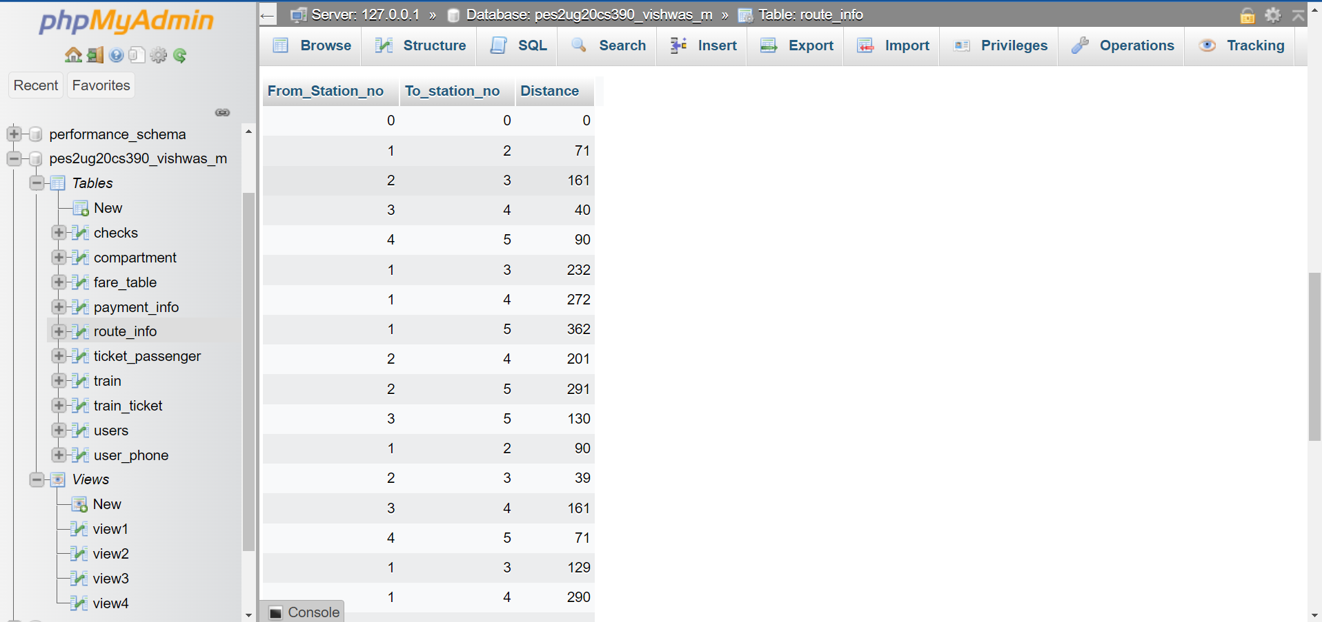

3) Retrieve the Train no of train which is leaving Bengaluru and arriving at Chennai with compartments availability greater than 10

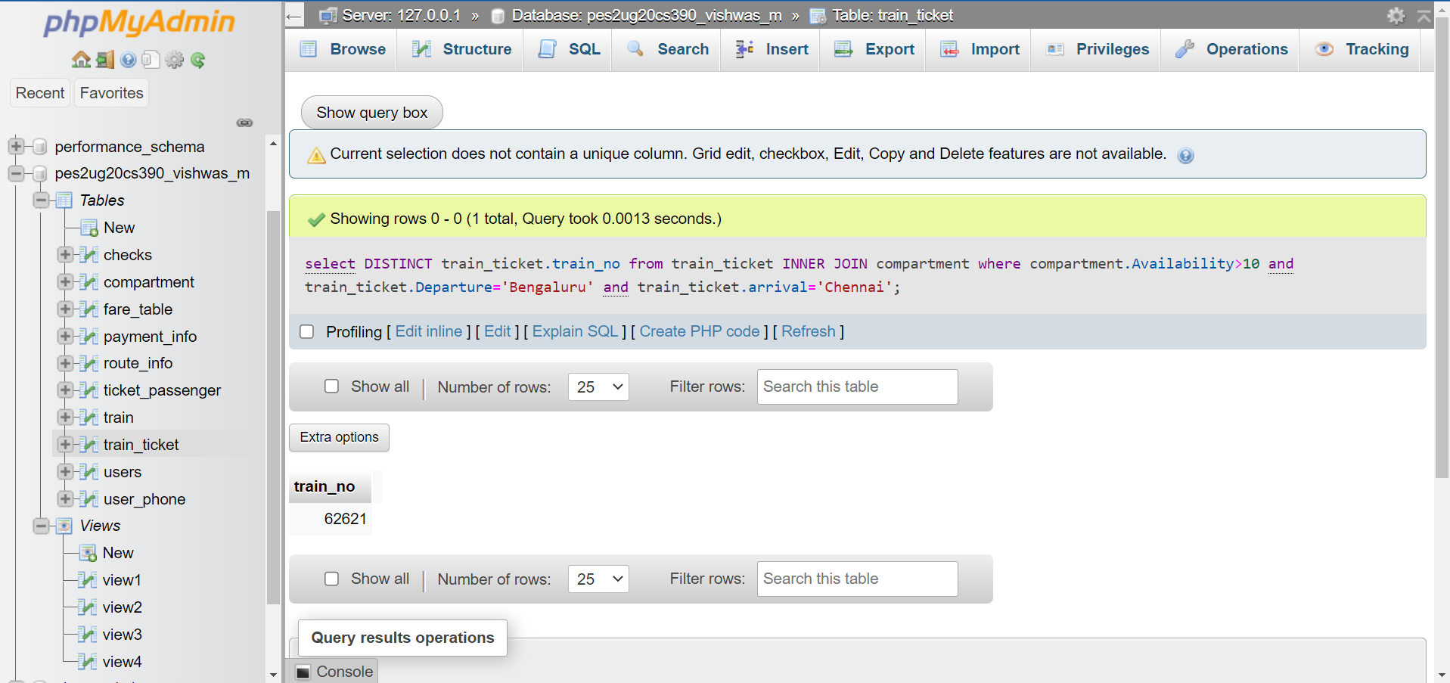

4) Retrieve first and last name of users who have booked a ticket with price greater than 500

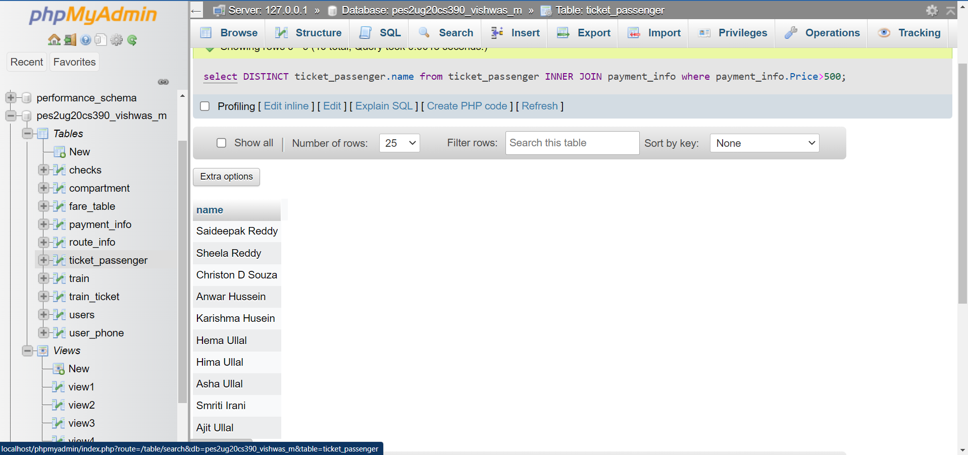

5) Retrieve the first name, last name, DOB and ticket PNR if they’ve bought it for all users.

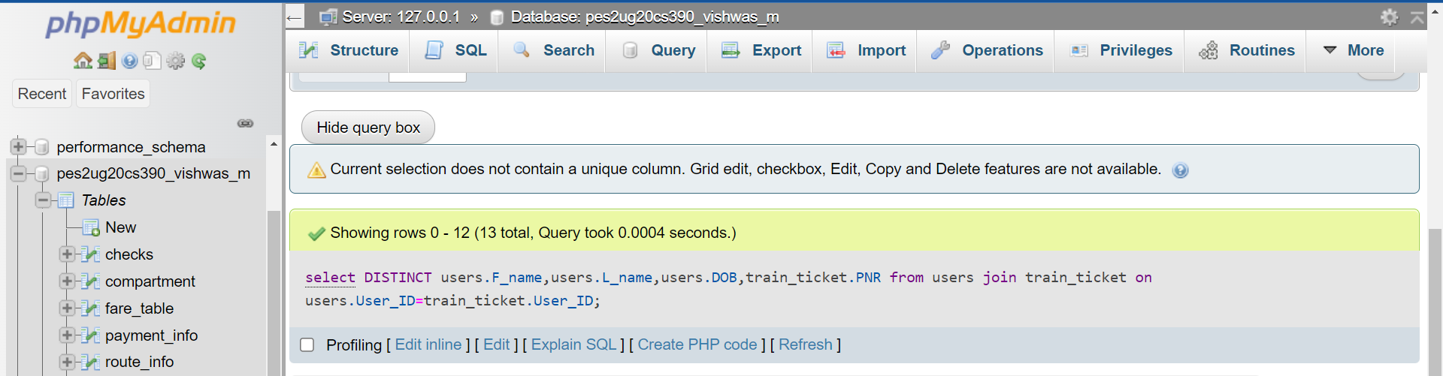

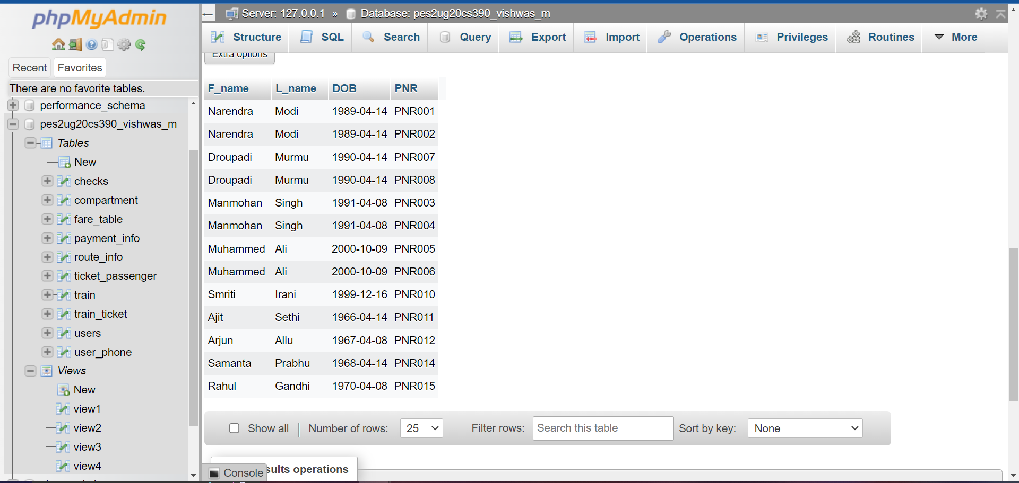

6) Retrieve the first name, last name, of the Users who have not bought a ticket.

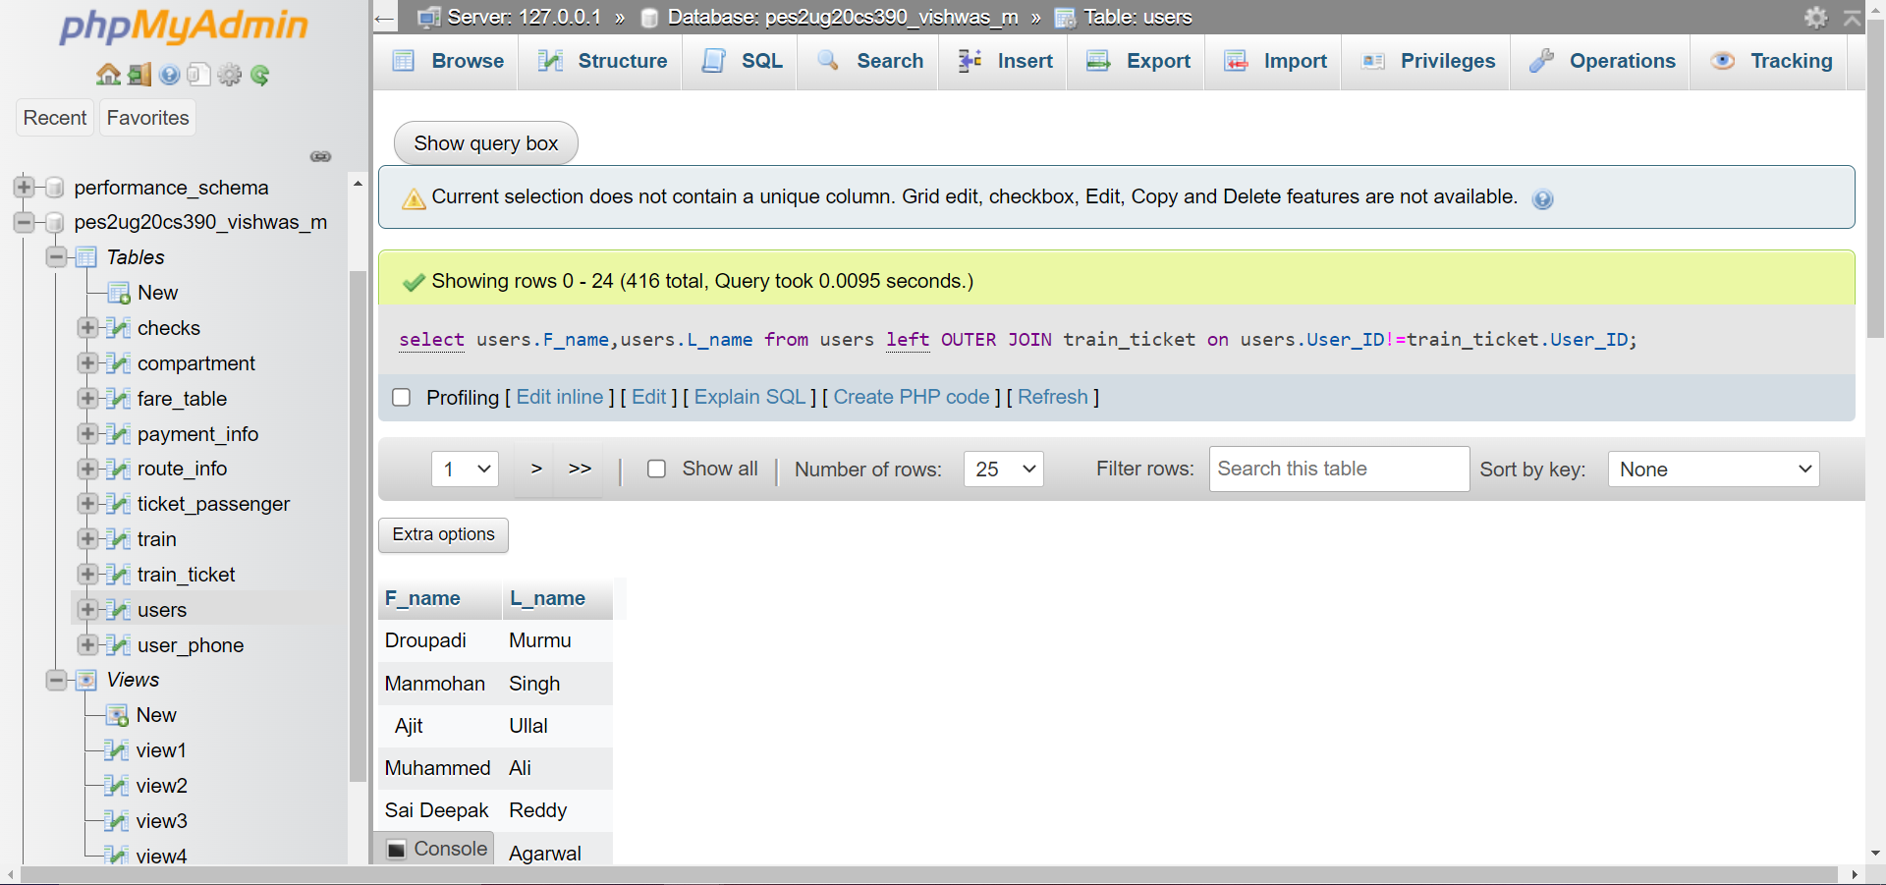

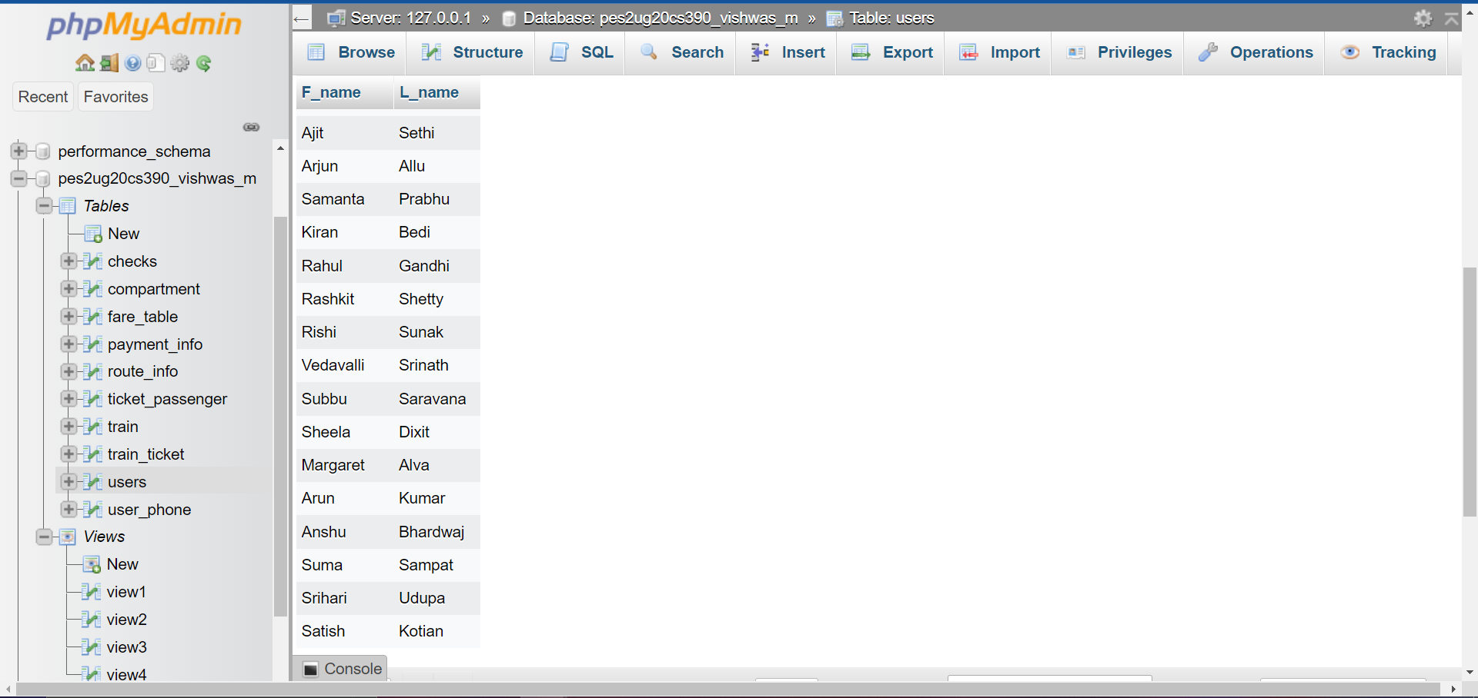

7) Retrieve the ticket PNR, Train number, travel date and along with all users first name and last name.

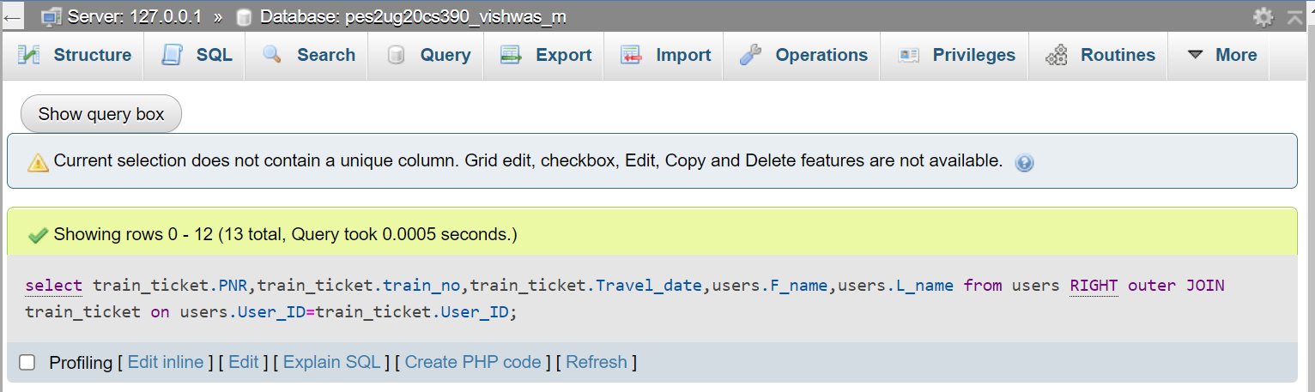

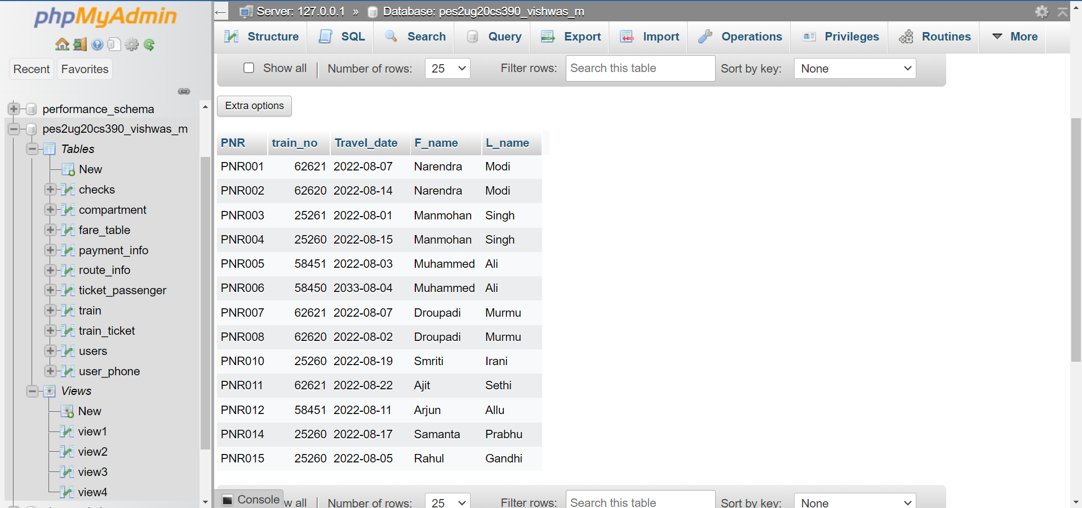

8) Retrieve the user id if they’ve travelled in a train along with train id and name of all trains.

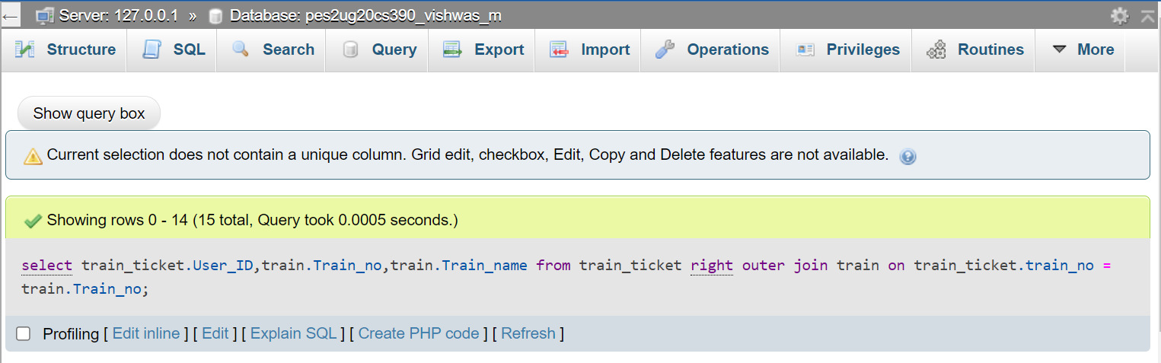

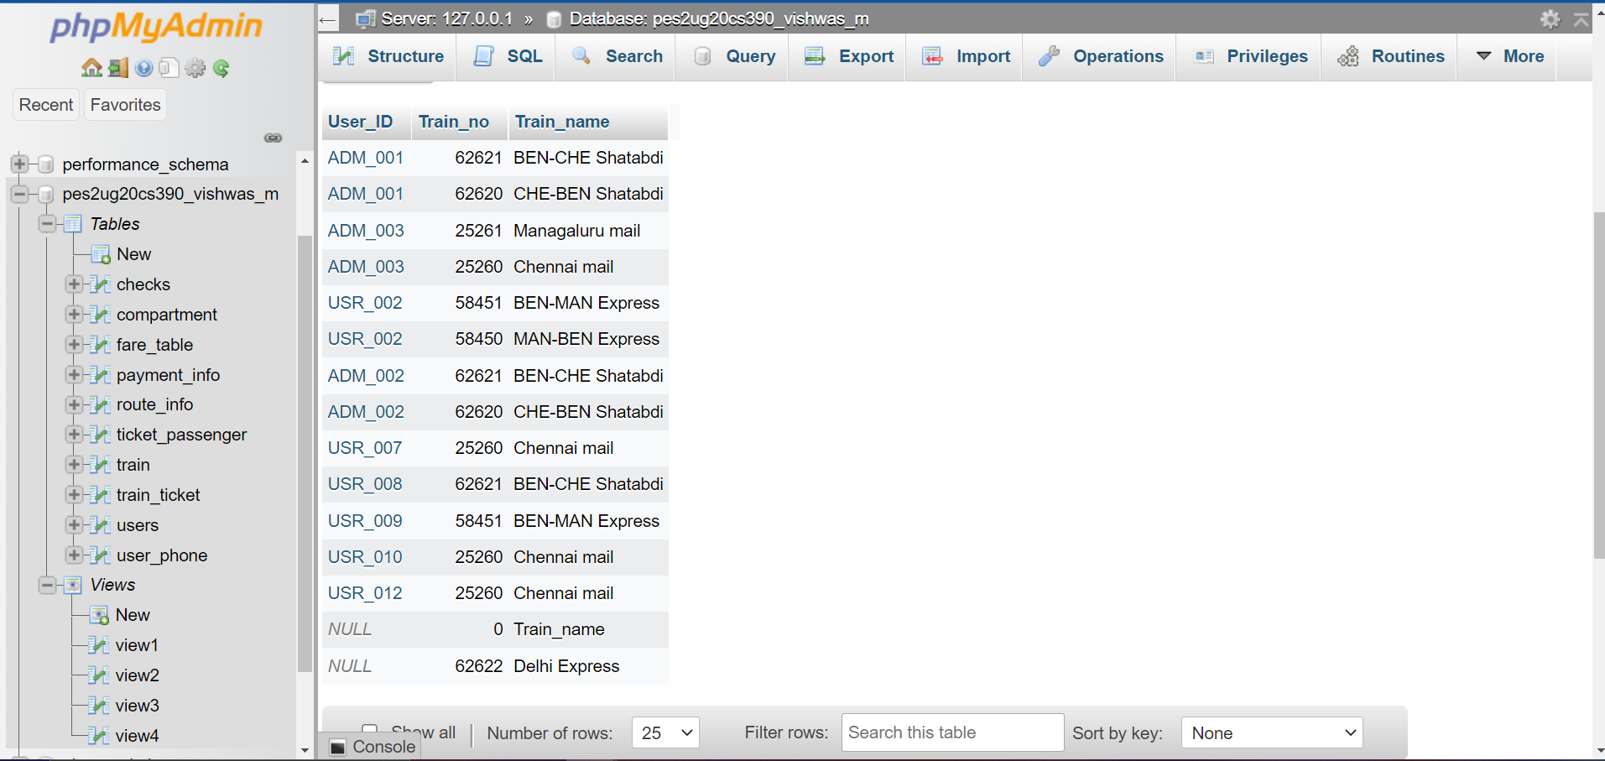

9) Retrieve the train no of trains whose destination is not Mangaluru. (Correlated)

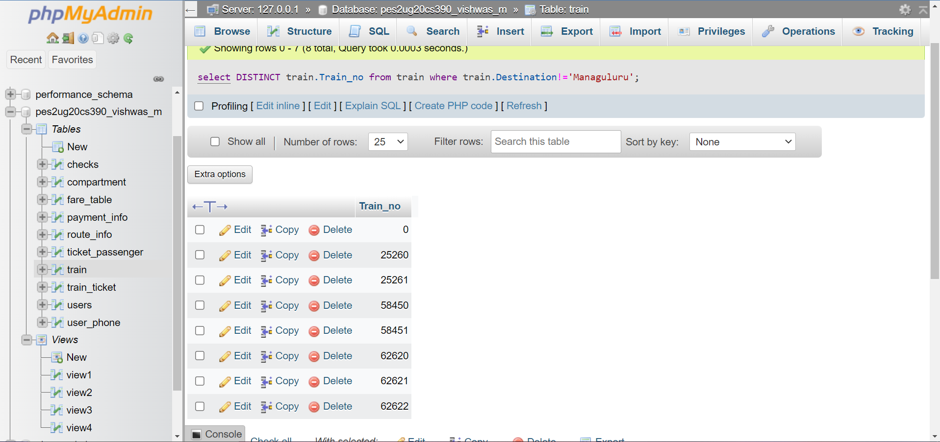

10) Retrieve the User ID who has spent more ticket price than the average ticket price.

(Uncorrelated)

